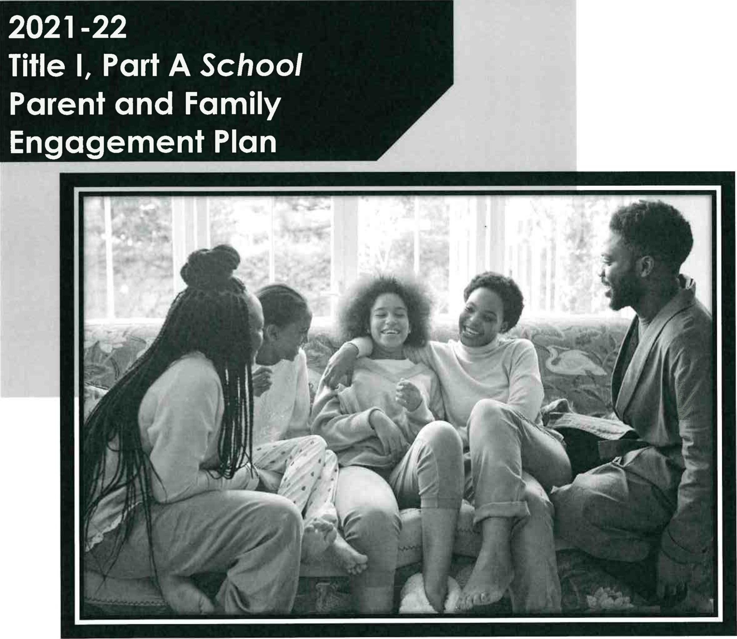
School Name: Mt. Herman ESC School #: 1 64

TABLE OF CONTENTS
OVERVIEW 3 ASSURANCES 4

NEEDS ASSESSMENT 5

Previous Year Financial and Programmatic Outcomes5
Fiscal Overview from the Previous Fiscal Year5

Programmatic Overview from the Previous Fiscal Year5

Barriers 6
Overarching Outcomes/Goals for the Current School Year 7

COMMUNICATION AND ACCESSIBILITY 8

FLEXIBLE PARENT AND FAMILY MEETINGS10

INVOLVEMENT OF PARENTS and FAMILIES10

FLEXIBLE FAMILY MEETINGS1 1

REQUIRED ANNUAL MEETING1 1 REQUIRED DEVELOPMENTAL MEETING12

BUILDING CAPACITY14

BUILDING THE CAPACITY OF PARENTS AND FAMILY MEMBERS 14
PARENT AND FAMILY ENGAGEMENT EVENTS 15

PARENT COMPACT17

INSTRUCTIONAL STAFF18

BUILDING THE CAPACITY OF TEACHERS AND STAFF MEMBERS
COLLABORATION OF FUNDS20

3

OVERVIEWTITLEONE
DUVAL COUNTY PUBLIC SCHOOLS
The Duval County Public School District Local Educational Agency (LEA) can only receive Title l, Part A funds if it conducts outreach to all parents and family members and implements programs, activities, and procedures for the involvement of parents and families consistent with Section 1116 of the Elementary and Secondary Education Act (ESEA) as amended by the Every Student Succeeds Act (ESSA) of 1965. The programs, activities, and procedures shall be planned and implemented with meaningful consultation with parents of participating children.
School level plans are required to be developed with the input of parents and families to improve student achievement and performance. The planning process can also include meaningful consultation with employers, business leaders, and philanthropic organizations. This template will assist schools with the best practices aligned to federal, state, and local expectations for compliance.
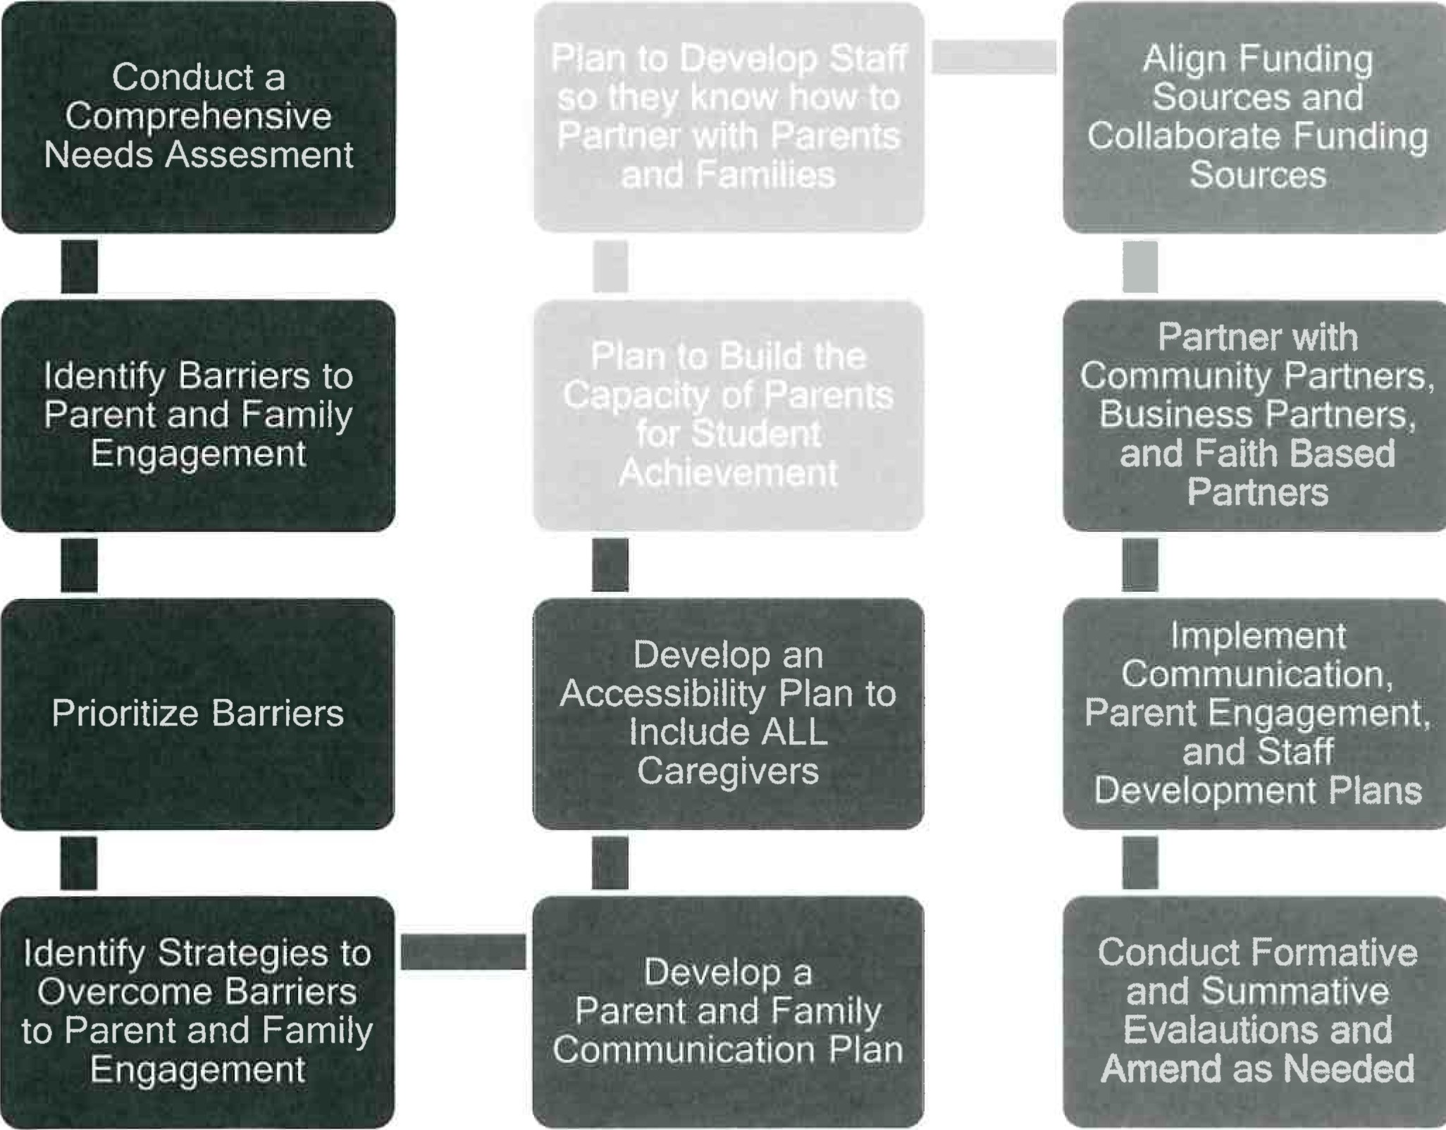
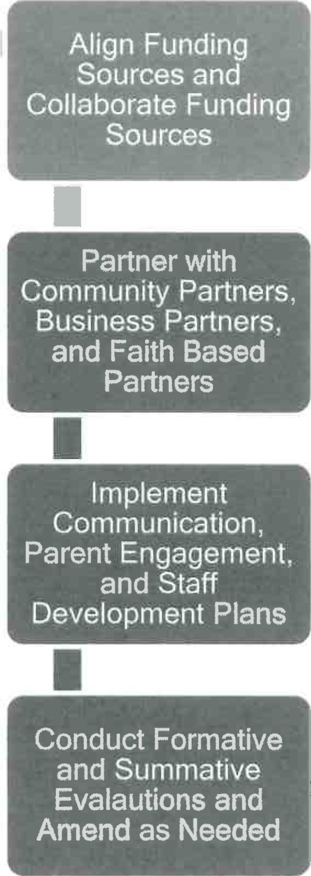
Below is an approach that can be used for Parent and Family Engagement.
"
"Treat children like they make a difference and they wi//.

ASSURANCES
l, Tina Wilson, do hereby certify that all facts, figures, and representations made in this Federal Parent and Family Engagement Plan are true, correct, and consistent with the statement of assurances for these waivers. Furthermore, all applicable statutes, regulations, and procedures; administrative and programmatic requirements; and procedures for fiscal control and maintenance of records will be implemented to ensure proper accountability for the expenditure of funds on this project. All records necessary to substantiate these requirements will be available for review by appropriate local, state and federal staff. I further certify that all expenditures will be obligated on or after the effective date and prior to the termination date of the project. Disbursements will be reported only as appropriate to this project, and will not be used for matching funds on this or any special project, where prohibited.

The school will be governed by the statutory definition of parent and family engagement, and will carry out programs, activities, and procedures in accordance with the definition outlined in ESEA Section 8101;

Engage the parents and family of children served in Title l, Pan A in decisions about how Title l, Part A funds reserved for family engagement are spent [Section 1116(b)(1) and
Jointly develop/revise with the family that has custodianship of the student the school parent and family engagement policy and distribute it to parents of participating children and make available the parent and family engagement plan to the local community [Section
Engage parents and family, in an organized, ongoing, and timely way, in the planning, review, and improvement of programs under this part, including the planning, review, and improvement of the school parent and family engagement policy and the joint development of the school wide program plan under section 1114(b)(2) [Section 1116(c)(3)];

Use the findings of the parent and family engagement policy review to design strategies for more effective parent and family engagement, and to revise, if necessary, the school's parent and family engagement policy [Section 1 1 1
If the plan for Title I, Part A, developed under Section 11 12, is not satisfactory to the parents and family of participating children, the school will submit parent and family comments with the plan when the school submits the plan to the local educational agency [Section
Provide to each parent and family an individual student report about the performance of their child on the state assessment in at least mathematics, language arts, and reading
Provide each parent and family timely notice when their child has been assigned or has been taught for four (4) or more consecutive weeks by a teacher who is not certified within the meaning of the term in 34 CFR Section 200.56 [Section 1 1 12(e)(1)(B)(ii)]; and Provide each parent and family timely notice information regarding their right to request information on the professional qualifications of the student's classroom teachers and paraprofessionals [Section 1 1 12(e)(1 )(A)(i)(l) and Sectionl 1 12(c)(1
*click to select each assurance, this page will require an original signature and submission to the District.

Tina Wilson 7/15/2021
Signature of Principal/School Administrator Date Signed

NEEDS ASSESSMENT
The Needs Assessment is the foundation of the Parent and Family Engagement plan. When meeting with parents and stakeholders, data from the needs assessment process provides previous year and trend data that can be used to make decisions about plan implementation for the upcoming year. That way decisions are not arbitrary but data-driven and purposeful.
Previous Year Financial and Programmatic Outcomes
Fiscal Overview from the Previous Fiscal Year
(this section is not required for new Title / Schools)
Total Parent and Family  Allocation from the Previous Yea r | Total Funds Expended | Total Funds Remaining
$ 3,200.00 | $ 2,476.56 | $ 723.44
If funds remained at the end of the year, explain why funds weren't fully expended and how parents will be engaged to plan for funds to be fully expended during the current plan year
Due to the pandemic, we had to scale back our activities because some parents were unwilling to participate until they felt it was safe to return. As things return to normal, we believe that more parents will participate more, and all funds will be expended.
Programmatic Overview from the Previous Fiscal Year
Summative Overview of the Parent Total Visits to the Parent Resource Room  (Must be documented on the  Resource Room Sign in Sheet) | Resource Room  Total Resources Checked Out from the Parent Resource Room | What plans do you have to fully use the Title I Parent Resource Room?  (include inventory that was not returned or any other information pertaining to parent involvement resource room
4 | 0 | To market it and to make it available for parents to complete DCPS surveys and school surveys.
Summary of Parent Engagement Events from the Previous Year
Name of Activity | Number of  Participants (this number should equal the number of participants listed on sign in sheets in Digital Compliance | Results of Evidence of Effectiveness (How do you know the parents learned what the activity was intended to provide?  Responses such as sign-in sheets or survey results are not sufficient.)
Annual Meeting (Beginning of Year) | 9 | Feedback from Forms Survey: "Thank you." "Virtual is not as good as face-toface."
(this section is not required for new Title / Schools)
Developmental Meeting (End of Year) | N/A | Rescheduled to 4/23/21.
Mid-year Stakeholders Meeting | 14 | Evaluation Forms: "Good Job', "Thank ou"
Storywalk | 12 | Evaluation Forms: "Everything was great!" "Loved the harvest idea."
Adapt-A-Book | N/A | Rescheduled to 4/30/21
Schools may add additiona/ lines as it is aligned to the Parent and Family Engagement Plan from the previous fisca/ year - activities must match activities included on the Parent and Family Engagement Plan from the previous schoo/ year. [fan activity wasn't held, a 0 should be included for the "Number of Participants" column with an explanation why the event wasn't he/d in the "Results" column.
Summary of the evaluation information and parent feedback collected from the Developmental Meetin held to su ort the develo ment of this Parent and Famil En a ement Plan.
Parents would like to see the Storywalk and the Adapt a book activities again. They found that they were activities that they could also do at home with their students
Barriers
Using previous year financial and programmatic outcomes; district and school climate data; parent perception data; data from SAC meetings; parent attendance data; observational data; parent survey data; data from the Title I Developmental meeting; parent interviews and focus groups; teacher and administrator feedback; other forms of needs assessment data; and carry out a needs assessment process. Then, describe the barriers that hindered the participation and involvement of parents and family members during previous school years.
1 . Barrier 1: The threat of COVID-19 prevented parent participation on a larger scale.
- Barrier: 2: The restrictions imposed by the CDC guidelines halted mass gatherings.
- Barrier: 3 Fear of the unknown prevented parent participation in school events.
- Barrier: 4 Ineffective communication about safety measures that were put in to place.
- Barrier: 5: The fact the English is not the family's primary written language.
- Prioritize the TOP THREE the barriers (it may be possible to combine some)
- Describe the steps that will be taken during the upcoming school year to overcome the parent and family engagement barriers (required - include how the school will overcome barriers for students with family members who have limited English proficiency, parents and family members with disabilities, and parents and family members who are migrants in accordance to ESSA Section 1 1 16
 |  | Barrier | Steps or strategies that will be implemented to eliminate or reduce the barrier
 | 1) | COVID-19 | Encourage faculty, staff, parents and stakeholders to get vaccinated.
 | 2) | Communication | Advertise and publicize the safety measures being im lemented b the school.
 | 3 | Lan ua e | Translator will be rovided forb the District.
Overarching Outcomes/GoaIs for the Current School Year
Considering your barriers and the strategies that are intended to reduce or eliminate them, what are the overarching outcomes/goals for the current school year for parent and family engagement?
The goal is to increase the number of parent/guardian participation in the education of our children.

COMMUNICATION AND ACCESSIBILITY
Communication is an extension of Needs Assessment as trend data has shown that parents comment that communication processes should be improved so they are fully engaged.
Accessibility
Describe how the school will provide full opportunities for all parents and families (keeping in mind the diverse makeup of 21 ^{st} Century families) to participate in all parent and family engagement activities. This includes strategies for parents who have specific needs such as parents with special transportation needs. parents who work multiDle jobs, court appointed parents, parents who are disabled. parents who speak English as a second languaae, migrant parents, parents with multiDle children in multiple schools, guardians, guardians with multiple students in a home, etc. Specifically, how will barriers be removed to ensure parents/guardians/family units are a part of their child's education?
Barriers, that prevent parent participation in a child's education, will be removed in a variety of ways. We will work to eliminate barriers imposed by COVID-19 by providing information on vaccine sites and their availabilities. As it relates to communication, we will provide school information in multiple social media outlets. Finally, we will provide school communications in the student's primary language.
Describe how the school will share information related to school and parent and family programs, meetings, school reports, and other activities in an understandable, uniform format and in Ian ua es that the arents and families can understand?
Parent communication wilt be sent home in the student's native language. Other languages are available upon request.
What are the different languages spoken by students, parents and families at your school?
English and Spanish
COMMUNICATION
(1) Describe how the school will timely communicate information about Title l, Part A programs and activities during the year. (2) How will communication take place for parents with the different languages mentioned in the question above if applicable? (3) Include the tools and resources that will be used for communication.
- Information concerning Title I programs, and activities will be communicated via Kaymbu, flyers, emails and telephone calls.
- Communications will be translated into other languages upon request.
- Computers, telephones, flyers, Kaymbu
How will the school describe and explain (1) the curriculum at the school (2) the forms of assessment used to measure student progress (3) the achievement levels students are expected to obtain? 4 in alla licable Ian ua es?
- Open forum with parents, Word documents sent home, Power Point presentations
- Data folio assessments, Teacher created tests, ULS assessments, FSAA
- IEP Team, FSAA
- All forms of communication will be translated upon
(1) What decision-making opportunities are available for parents at the school site? (2) How will the school communicate o ortunities for arents to artici ate in decision makin ?
- Parent input helps us to make SAC decisions and decide what workshops that we offer
- Flyers, letters, emails, post cards
How will the school submit parents' and families' comments to the district Title I office if there are parent concerns about the implementation of the Title I school-wide plan that is not satisfactory to them? ESEA Section 1116
Comments can be submitted via the Parent Liaison
Comments can be submitted via the Volunteer Liaison
Comments can be submitted via the Parent Kiosk to send an email
Provide them with the telephone number to the Title I Office
(l) How will the school publish and communicate THIS required Title l, Part A Parent and Family
Engagement Plan to Parents and families (technology cannot be the only option). (2) How will this Ian be communicated in all of the Ian ua es that a I to our school?
- It will be included in the Student Handbook, the Parent Handbook, a copy will be maintained in the PFEP Folder in the PFEP Area, and it will be included under the Parent Tab on the school's website.
- All information will be translated upon request.

FLEXIBLE PARENT AND FAMILY MEETINGS
Schools receiving Title IJ Part A funds are required to convene an Annual Meeting. This meeting should be held at a convenient time for parents. Parents of participating children in the school shall be invited and provided with adequate notice and encouraged to attend the Annual Meeting. This meeting will inform parents of their school's participation under ESEA Section 1 1 16 and explain the requirements of the Title l, Part A grant and what is available to parents and the right of parents to be involved. [ESEA Section 1116 (c)
INVOLVEMENT OF PARENTS and FAMILIES
Explain how the school involves parents and families in an organized, ongoing and timely manner in the planning, reviewing, and improvement of Title I programs including involvement in decision makin of how Title l, Part A Schoolwide funds are used ESEA Section 1116 c 3
We have found that more parents are involved in Title I decision-making process when we combine our meetings with popular school activities and events. Therefore, we include our announcements and hold our meetings in tandem with other meetings and events (SAC, School Opening, Special Olympics, etc.).
How will the school provide, with Title I funds, transportation, childcare, or home visits such services that relate to parent engagement to ensure barriers are removed so parents can participate in engagement events? [ESEA Section 1 116 (c)(2)]
Transportation - J TA Bus Passes & JAX Connexion
Childcare - In-house Child Care
Home Visits - School Social Worker
Additional Services to remove barriers to encourage event attendance - Provide a translator at meetings.
FLEXIBLE FAMILY MEETINGS
How was parent input gained from the majority of parents about the times that best met their need for arent involvement meetin sand activities? ESEA Section 1116 c 2
- Forms survey was sent out via email.
Paperback copies went home to be completed and returned.
- Survey Monkey was set up via the Parent Kiosk Engagement forms
What documentation does the school have that parent needs for meeting times, transportation needs, childcare, and home visits for family engagement were assessed?
Parent engagement forms were sent home and completed.
How flexible meetings will be offered to accommodate parents? Check all that apply.
AM Sessions based on documented parent feedback
CJ PM Sessions based on documented parent feedback
Mixture of AM & PM Sessions (Some meetings will be provided in the morning and evening)
AM & PM Sessions (ALL meetings will be provided both in the morning at in the evening)
Other Phone Conference, Virtual Meetings
REQUIRED ANNUAL MEETING
Describe the specific steps your school will take to conduct the Beginning of Year Annual Meeting to inform parents and families of participating students about the schools Title I program and parent and famil en a ement activities. ESEA Section 1116 c 1
1 . Step 1: Written notifications sent home
- Step 2: Blackboard
- Step 3: Kaymbu
- Step 4: Flyers
- Step 5: School Website
- Step 6: Facebook
- And so. on as needed....
Describe the nature of the Title l, Part A Schoolwide program that will be shared with parents during the Annual Meetin . Feel free to use the PowerPoint on the Federal Pro rams site.
reas of Focus: Student Achievement, Parental Involvement, Quality Teaching and Supplemental Services.
Describe how the Annual Meeting will cover (1) the adequate yearly progress of students broken down by subgroups, (2) school choice, and (3) the rights of parents when schools receive Title l, Part A funds. Feel free to use the PowerPoint on the Federal Pro rams site.
- Elementary, Middle and High School students will draw data from District Assessments, ULS and FSAA Testing.
- All of our students at Mt. Herman Exceptional Student Center come to us via the Placement
Office.
- Parents are involved in the Developmental Meetings, PFEP Plans and the Annual Review.
How will the school ensure parents without access to technology will receive notification of parent events, communication, information about parent events, school updates, and student progress u dates?
Memos will be sent home via the "Home-School" notebooks, School Messenger and Kaymbu services ill be utilized.
REQUIRED DEVELOPMENTAL MEETING
The Developmental Meeting is held at the end of the year. It can be looked at as an End of Year evaluation of your Title l, Part A Parent and Family Engagement process. Additionally, it is an opportunity to connect with parents to start planning for the upcoming year. Even if your school is not Title I the following year, the best practices of parent engagement should continue. This meeting should evaluate how well barriers were reduced or eliminated and celebrate the successes of the year.
Describe the steps and strategy that will be implemented to conduct the End of Year
Developmental Meeting to evaluate Parent and Family Engagement that occurred during the year and to re are for the u comin ear if the school continues to uali for Title l, Part A fundin
Step 1: Surveys will be sent out to assist in creating an agenda.

Step 2: Notices will be sent out to advertise the meeting
Step 3: A PowerPoint will be used to deliver the information
Step 4: Evaluation forms will be completed and analyzed to determine next steps.
Step 5: Results will be shared.

BUILDING CAPACITY
When a school receives Title l, Part A funds, it is responsible for building the capacity of each parent to improve their child's academic achievement. This includes activities and strategies for parents to understand challenging State academic standards; State and local assessments; how to monitor their child's progress and work; literacy training; how to use technology; and other strategies of how parents can assist their child with the learning process. All funds expended under this section should align to this section and to achieving the goals in the Title I Schoolwide plan by engaging parents and families. [ESEA Section
1 1 16
BUILDING THE CAPACITY OF PARENTS AND FAMILY MEMBERS
Reflecting on the needs assessment process, what is an overview of how the school will implement activities that will build the capacit for meanin ful arent and famil en a ement?
Parental activities, workshops and training sessions will be planned that augment the schoolhome educational relationship. We have strategically picked dates that do not conflict with dates of other major events. During the Developmental Meeting, parents suggested workshops that they were interested in, and we are prepared to offer that service to them.
How will the school implement activities that will build relationship with the community to improve student achievement?
We will partner with vendors and sponsor workshops that specialize in our area of need. Also, we will partner with the Jax Library to offer reading enrichment opportunities.
(l) How will the school implement the Title I Parent Resource Room to support Parent and Family Engagement? (2) Explain how the Parent and Family Engagement Room is advertised to parents. (3) Explain how school staff (teachers and office staff) are trained on how to use the Parent Resource Room with arents.
- Make the PFEP Area easily accessible and highly visible.
- Flyers in the Front Office, Arrows pointing to the area and memos sent home to advertise the PFEP Area.
- The staff is available to direct, assist with navigating the technology and offer assistance with checking out items.
If there are additional ways resources are provided for parents through the use of Title l, Part A funds, how are they provided and what trainings are provided to adequately prepare parents to use the resources and materials at home with their children?
Read-A-Long books are available for checkout and workshops are planned that offer assistive technology for parents to take home to assist their children in reading comprehension. All funds this year will be spent on Parent Engagement Activities. *Canvas bags for parents to collect handouts/resources
*Non district printing for fliers, reminders and invitations
*Sensory Science money will be spent on 3-fold science board and supplies for students to participate in the Science Fair. Due to the nature of Mt. Herman, Sensory science boards will be made with the parents and student. Parents will be shown how to make a board with their student and then go home with the board and work with their student. Our students are unable to complete a science board independently. Parent evening will be show various experiments and ways to complete an experiment and help their student make a board.
*Adapt-a-book. Books will be adapted to allow students with disabilities to read books and improve reading/listening skills. These books are laminated with Velcro pictures to choose from and to attach in the correct position. Parents are given a book and then the book is adapted, using each page in the book, to have items to Velcro to each page. This is used to help student comprehension. Stuffed animals will also become animated when hooked up to a switch so that the student's learn how to hit the button for answering questions and for understanding.
*Storywalk - stations are made for each concept and item (using visual posters of items) that needs to be collected by the character in the book. Parents will learn how to do a story walk using a book to help their children with reading comprehension.
PARENT AND FAMILY ENGAGEMENT EVENTS
If Parent and Family Engagement events are funded with Title l, Pan A funds, they must be supplemental and cannot supplant activities that are funded with state and local funds. Additionally, events should contribute to the achievement of goals outlined in the Title I Schoolwide Plan.
Name of Activity Person What will parents Month Activity wilt Evidence of
Responsible learn that will have a take Place Effectiveness measurable,
Anticipated impact on student achievement
Title I Annual  Meeting  (required) | Joseph  McDomick | Parents will gain a better understanding of how to support the teacher's instruction at home, thereby, increasing the opportunity for academic progress on the Datafolio. | September 2021 | Workshop  Evaluation Form,  Feedback,  Survey
Title I  Developmental  Meeting  (required) | Joseph McDomick | Parents will have the opportunity to evaluate the progress of the previous academic year and give suggestions for what the would like | March 2022 | Workshop  Evaluation Form,  Feedback,  Survey

Mid-year  Stakeholders  Meeting | Joseph  McDomick | Opponunity to share the progress of meeting the schoolwide goals. Also, a time to make adjustments to the calendar of events. | January 2022 | Workshop  Evaluation Form,  Feedback,  Survey
"Storywalk" | Tina Wilson | Interactive Family Educational Event to stimulate student responses to sensory items. | October 2021 | Workshop  Evaluation Form,  Feedback,  Survey
Community  Resource Fair | Sandi Locklear | Opportunity for parents/guardians to obtain information from vendors about the various services that are available to them. | March 2022 | Workshop  Evaluation Form,  Feedback,  Survey
Sensory  Science | Jeff Bellamy | Opportunity for parents/guardians to observe/participate in the science experiments facilitated by students. | January 2022 | Evaluation Form,  Feedback  Survey
Sensory Art festival | Janet Harris | Opportunity for parents/guardians to observe/participate in the art projects facilitated by students. Parents will learn what to do at home to encourage sensor art at home | November 2021 | Evaluation Form,  Feedback  Survey
Adapt-A-Book | Matt Take | Opportunity for parents/guardians to participate in a workshop that transforms a standard children's book into an Adapt-ABook for children with disabilities. | February 2022 | Workshop  Evaluation Form,  Feedback,  Survey

PARENT COMPACT
The LEA shall ensure that each participating school, in conjunction with the parents of participating students, has jointly developed a school-parent compact that describes the school's responsibility to provide high quality curriculum and instruction in a supportive and effective learning environment; addresses the importance of ongoing communication between teachers and parents; describes the ways in which each parent will be responsible for supporting their child ^{i} s learning; and is discussed with parents of elementary aged students.
As a Title I school, what evidence will you provide that will show that you have jointly developed a school-parent compact and that conferences were held with parents describin the com act?
Signed copies of the compact will be kept at the school and they will be referred to during conferences and parental meetings (to include IEP meetings).
How will the principal ensure required conferences are implemented with ALL parents ertainin explainin the Parent Com act?
All of our students, at Mt. Herman ESC, have disabilities and IEP Meetings are required to monitor their progress towards their goals. During those meetings, the Parent Compact agreement will be discussed.

INSTRUCTIONAL STAFF
The LEA shall ensure that each school implementing a Title I program devotes sufficient resources to effectively carry out high quality and ongoing professional development for teachers, principals, and paraprofessionals and, if appropriate, pupil services personnel, parents, and other staff to enable all students to meet the state's academic achievement standards.
The LEA shall ensure that all instructional staff working in schools, funded wholly or in part with Title l, Part A, meet the statutory requirements of being state certified. The LEA must ensure instructional paraprofessionals work under the direct supervision of a teacher.
If the LEA hires teachers or paraprofessionals to provide Title I services to private school students, the LEA shall ensure the teachers are state certified and paraprofessionals are highly qualified. The LEA shall ensure that paraprofessionals providing direct instruction to participating students are under the direct supervision and in close and frequent proximity to a state-certified public-school teacher.
As a Title I school, what evidence will you provide that will show that you (1) notification informing parents that their child was assigned or was taught for four or more consecutive weeks by a teacher who was not properly licensed or endorsed (2) provided a list of teachers who were ineffective, out-of-field, or inexperienced according to the statewide definitions described in Florida's A roved ESSA State Plan.
We send out notifications (on school letterhead) to parents during the first and second semesters informing them of the status of their child's teacher. These time periods coincide with the FTE Survey weeks, and we are required to send written notifications to parents/guardians with copies sent to the Certification Office.
BUILDING THE CAPACITY OF TEACHERS AND STAFF MEMBERS
When a school receives Title l, Part A funds, it is responsible for educating teachers, specialized instructional support personnel, administrators, and other staff, with the assistance of parents, in the value and utility of contributions of parents, and in how to reach out to, communicate with, and work with parents as equal partners, implement and coordinate parent programs, and build ties between parents and the school. To the extent possible, parents should be involved in the development of training for teachers and educators to improve the effectiveness of training. [ESEA Section 1 1 16(e)(3)]
Describe the professional development activities the school will provide to educate teachers, specialized instructional support personnel, principals, and other school leaders and other staff on...
- The assistance of parents and families and in the value of their contributions.
- How to reach out to, communicate with, and with parent and families as equal partners.
- Implementing and coordinating parent and family programs and building ties between parent and families and the school.
Name of Activity Person Correlation to Month Evidence of Effectiveness Responsible Student Activity
Achievement will take
Place
Poverty Simulation with the Title / team | Mr. Black | Improved ability for staff to work with arents and families | Dec  2021 | Sign-in sheets, evaluation sheets, fo//ow up with teachers
"The IEP from A to Z" | Wilson,  McDomick,  Howard,  Locklear,  Hisole | Improved ability for staff to work with parents of ESE students. | August 2021 | Sign In sheets, Evaluation forms, Walkthroughs
Calm Classroom | Wilson,  McDomick | Improved ability for staff to maintain a calm classroom environment. | August 2021 | Sign In sheets, Evaluation forms, Walkthroughs
Kaymbu | Wilson | Adding Daily Notes to the communication platform used by arents. | Sept 2021 | Sign In sheets, Evaluation forms, Walkthroughs, Usage Reports
Grade Level  Common  Planning | Teachers | Grade level collaboration to ensure curriculum ali nment | October 2021

20

COLLABORATION OF FUNDS
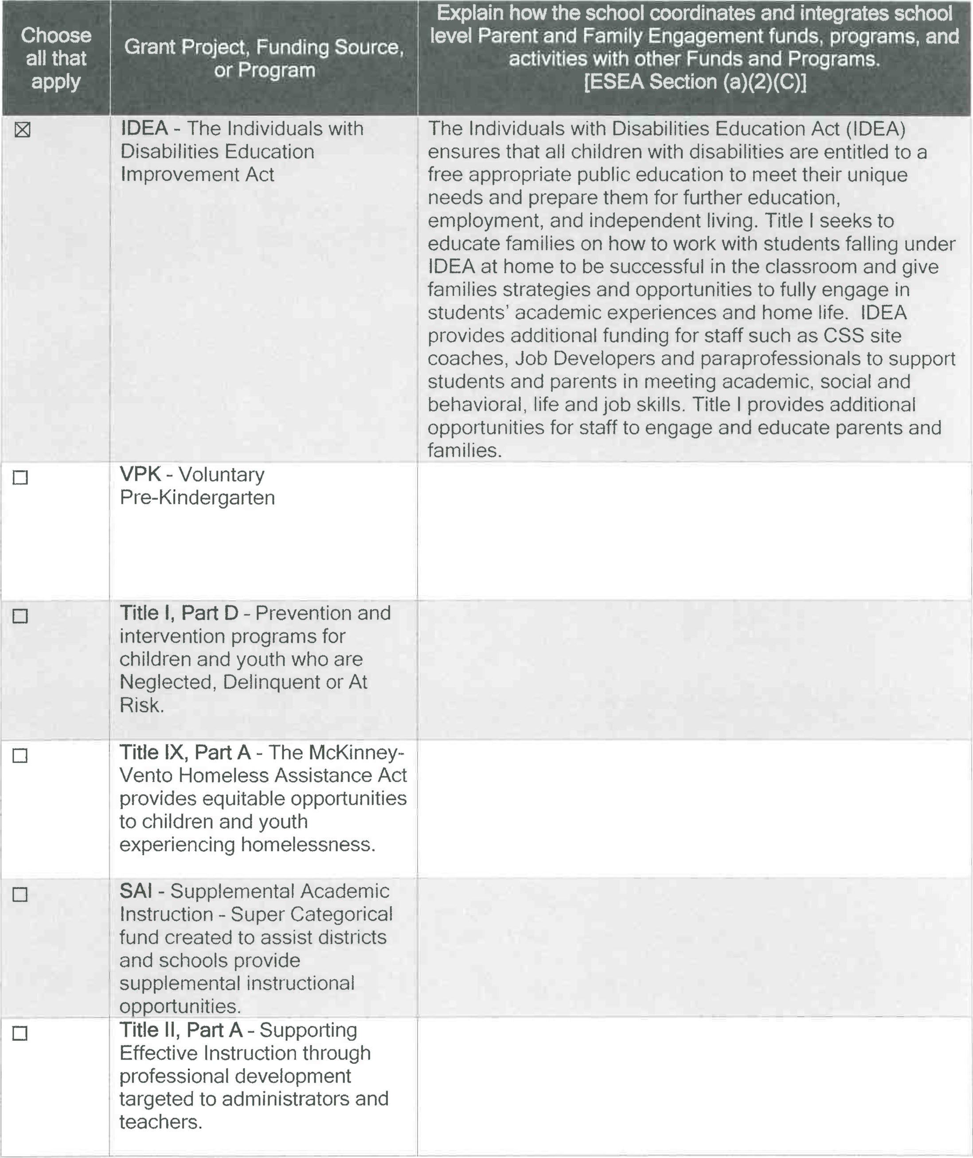
Schools may add lines as needed.

