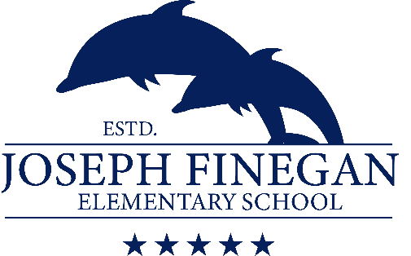

2020 – 2021 Uniform Policy

Who: All Students (Grades Pre-K through 5th)
- Our Uniform Policy was adopted during the 2010-2011 school year.
- All Students are expected to participate, and school uniforms must be worn daily.
- There is not an, “Opt-out” policy regarding the school uniform policy.

Clothing Items: | Color: | Style:
Tops: | Solid: White, red, or navy | Collared shirt or long-sleeved (polo/golf styled) shirt
Bottoms: | Solid: Black, navy, khaki, or  denim | Pants  Shorts - athletic/basketball style are permitted.  Jeans/Overalls - may not have holes larger than the size of a quarter; no “distressed”/fashion jeans.  Skirts/Skorts  Leggings - may only be worn under shorts, skirts/skorts, dresses/jumpers.
Dresses/Jumpers: | Solid white, black, navy, khaki, or red. | Short or Long-sleeved dresses with a collar.
Outerwear: | Your choice | Sweater, sweatshirt, jacket, or coat
Shoes/Socks: | Your choice | Any style – with closed heels, or back straps.  No slippers, flip-flops, or shoes with heels higher than 1” - due to safety reasons.

What: Uniform Policy Guidelines:

- Our Uniform Policy will adhere to the requirements of the DCPS General Code of Appearance.

When: Every Day:

- Uniforms, are required to be worn every school day.
- On Fridays, students are permitted to wear Finegan “Spirit Shirts,” which include: school club shirts, “Purple-Up” shirts, and “Spirit shirts” from previous school years.

Why: Safety Learning & School Spirit:
- We believe uniforms promote a disciplined, and safe learning environment, while also minimizing distractions and encouraging school spirit. Wearing uniforms promotes unity and minimizes the socioeconomic differences that students may otherwise experience. It also allows for administration and staff to recognize intruders on campus.

Implementation: In the event students are unable conform to the uniform policy set forth in this document. The following measures will be taken:
- Call home. Parents/caregivers will be given the option to bring the correct items to school, or the offer to have the student wear one of the extra uniforms we have on hand at the front office.
- A note will be sent home encouraging and reminding our parents/caregivers of the importance of following our uniform policy, and that non-conformity will limit and possibly prevent their student(s) from receiving and/or participating in:
- School clubs i.e., WFIN, K-Kids, LEGO Robotics, Garden Club, Green Club, etc.
- Silver and Golden Anchor Award recognition

It is our goal to ensure that all students feel safe and secure in their school. The Student Advisory Council has approved this uniform policy for the 2020-2021 school year. If purchasing uniforms is a financial burden, please contact Mrs. Velda Thomas at (904) 247-5996 for assistance.

